End_To_End_RAG Application_Using_Haystack_MistralAI_Pinecone_FastAPI

Create necessary files and folders

Create a virtual environment



Activate the environment



Setup.py

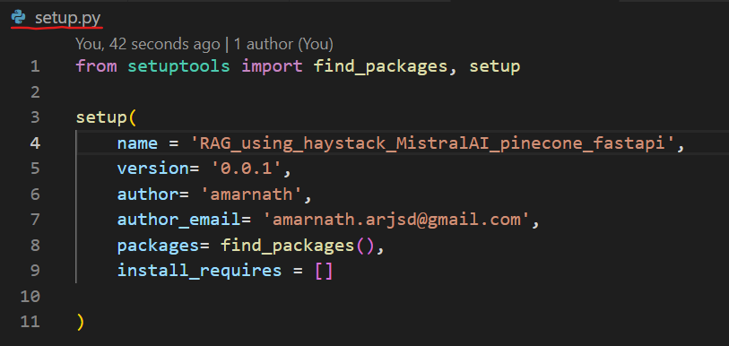

Requirements.txt

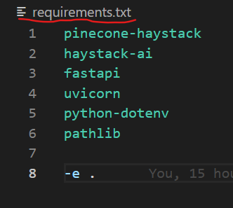

Install the packages

